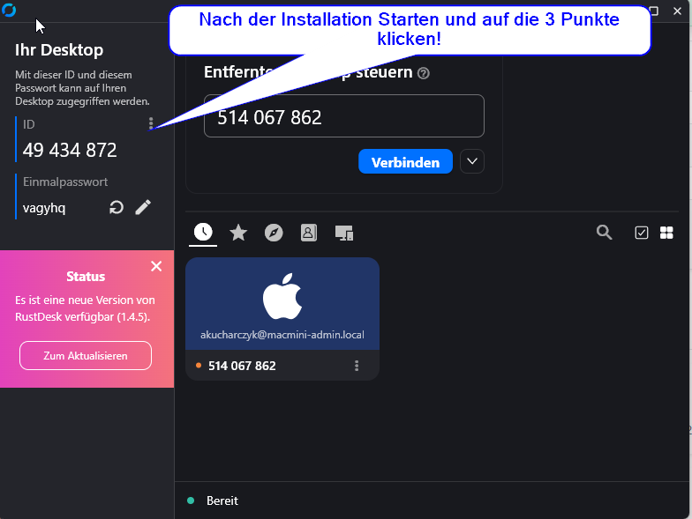

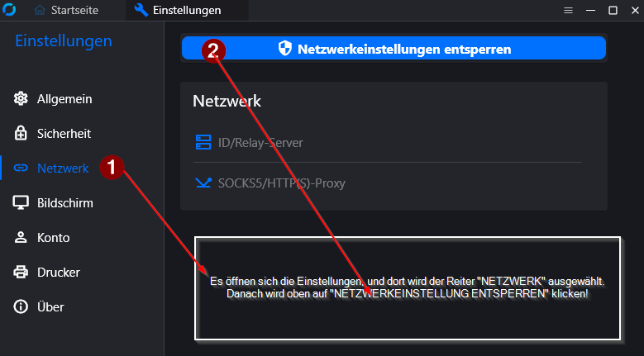

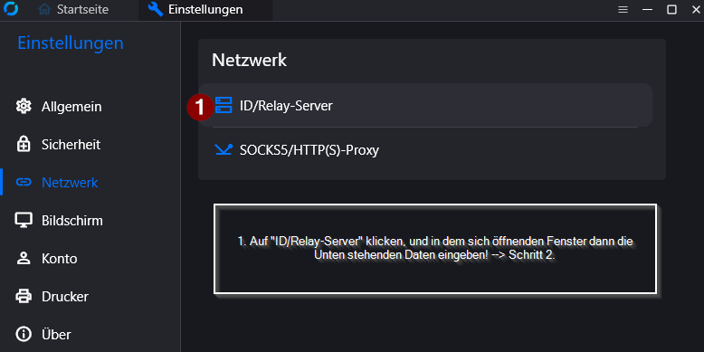
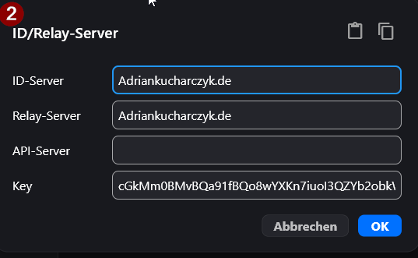

RustDesk ID/Relay-Server Konfiguration
ID-Server: Adriankucharczyk.de
Relay-Server: Adriankucharczyk.de
Key: cGkMm0BMvBQa91fBQo8wYXKn7iuoI3QZYb2obkWThnA=

